*Mission: Explore, Enlighten and Inspire All Things Arts! Vision: To connect the Arts to our communities to enrich quality of life!*

BOARD OF DIRECTORS

Annette Burns Presiding

Thursday July 20, 2023 at 4:30pm

Chenango Arts Council Conference Room

1. Call to order
2. Approval of FY 2023-2024 Budget
3. Approval of Minutes
4. Welcome New Board Members
5. Treasurer’s Report
   1. June 30, 2023 Financials
   2. Downtown Revitalization Initiative (DRI)
      1. Background – CAC awarded $570K to Renovate Theater
      2. Recommendation as $200K first draw (Sound and Lights)
      3. Recommendation of Denise Reppert and Alecia ONeill as signers for DRI/NBT Bank Transactions
      4. Board Vote
6. Committees
   1. Board Development
      1. Recommended Slate of Officers
         1. President, Denise Reppert
         2. Vice President, Mary El Emerson
         3. Treasurer, Joe Skundrich
         4. Assistant Treasurer, Roy Fuller
         5. Secretary, Lora Rowe
   2. Nominations from the Floor
   3. Vote Slate of Officers
7. Executive Director’s Report
8. Continuing Business
   1. Grants for Teachers Update
9. New Business
10. Adjourn

Next Exec Meeting

Thursday August 10, 2023 @ 4:30 via Zoom

NO FULL BOARD MEETING IN AUGUST

Next Full Board Meeting

Thursday September 21, 2023 at 4:30 at Arts Council

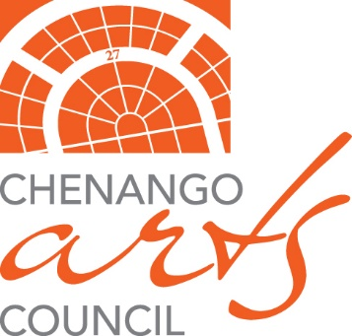

# 27 West Main Street, Norwich, NY 13815

## Board of Directors

**Annette Burns**

***President***

**Mary El Emerson**

***Vice President***

**Joseph Skundrich**

***Treasurer*Denise Reppert *Secretary***

**James Baldwin**

**Joni Eaton**

**Roy Fuller**

**Elaine Genute**

**Sarah Green**

**Greg LaMonica**

**Michelle Lash-Ruff**

**Virginia Lee**

**Megan McKown**

**Lora Rowe**

**Staff**

**Alecia ONeill**

***Executive Director***

**Mary Beth Miller**

***Program Development   
 Coordinator***